Driven Racing Oil™ Announces Exclusive Automatic Transmission Fluids
Huntersville, NC – Driven Racing Oil™ has launched its first exclusive formulation automatic transmission oils containing mPAO, the most innovative synthetic base oil available.
Driven’s new AT3 and AT6 feature multi-functional additives, corrosion inhibitors and foam suppressors for high temperature protection and shear stability, while also offering lower operating temperatures, reduced parasitic drag and smooth shifting. Each is specifically designed to meet the needs of road racing, oval track and drag racing automatic transmissions, with no additives necessary.
AT3 is recommended for use anywhere DEXRON III or Mercon fluids are specified. It can also be used in manual transmissions and transaxles like T-5, T-45, T-56. AT6 or others that specify multi-vehicle ATF.
AT6 is recommended for use in transmissions that specify Dexron VI and Mercon LV fluids. It is also suitable for use in Toyota Type T-III and T-IV, Honda ATF-Z1, NissanMatic D, J, & K, Diamond SP-II, SP-III, Mazda ATF M-V and most BMW, Audi and automatic VW transmissions.
Part Numbers: #04706 (AT3); Price: $10.99 (1 qt.)
#04806 (AT6); Price: $11.99 (1 qt.)
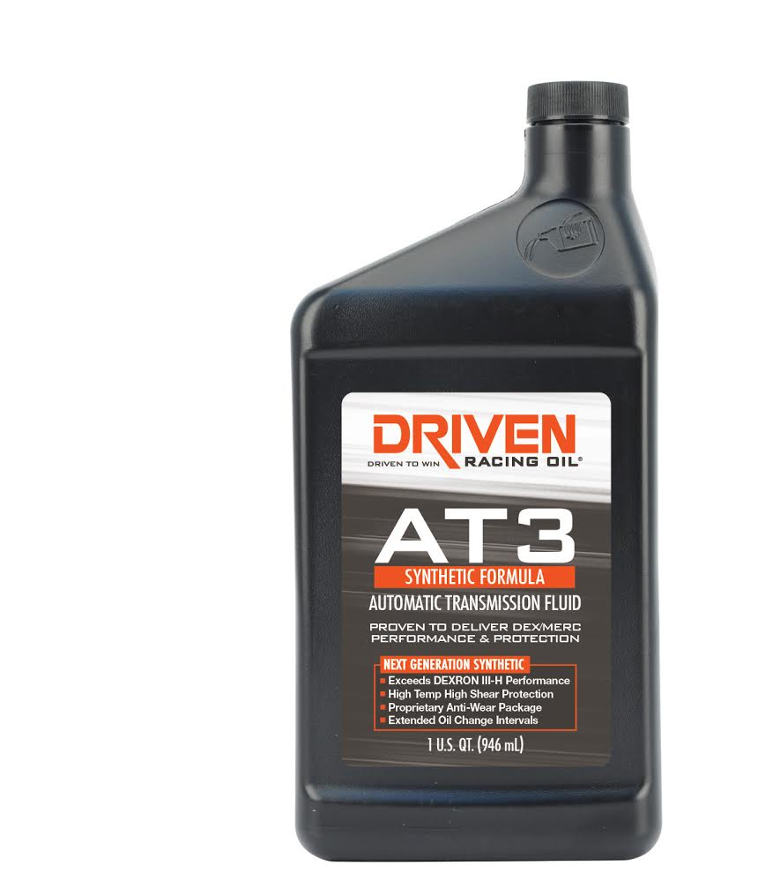
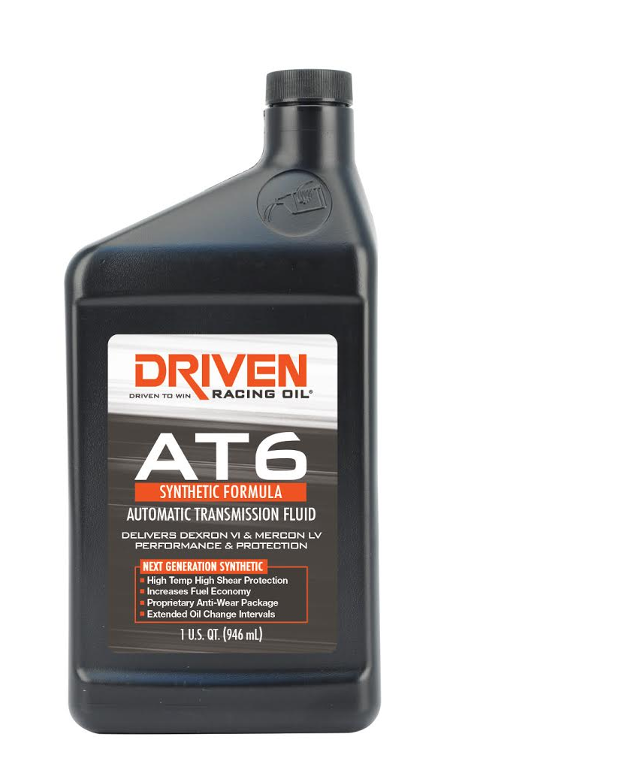

About Driven Racing Oil™
Driven Racing Oil™ utilizes cutting-edge lubricant technology and on-track research for maximum performance gains from all of its product offerings. Competition drives innovation, and Joe Gibbs Racing originally developed the Driven brand of oils to advance engine and driveline performance on the racetrack. From full-synthetic race oils to engine break-in oils and cleaners, Driven offers a wide range of race and street products that deliver performance, protection and value.

